TD BASE DE DONNEES :

3. VRAI
4. FAUX :
CORRECTION :
SELECT *
From departments;

5 . FAUX :
CORRECTION :
SELECT employee_id,last_name,salary*12,Salary
From employees ;
6.
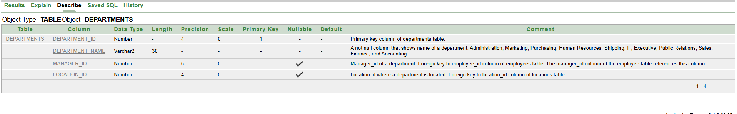

7,8.



9.
SELECT Distinct Job_id
From employees ;

